Parcel Panic
(July 14, 2024)
A misguided courier has mischievously misdirected your packages to storage lockers in various countries around the world. Parcel Panic is a cooperative deduction game where everyone, but you, knows your parcel’s location and contents! Geographic learning too! For 2-6 players, ages 8+.

Game Components:  - 34x17 game board  - 200+ country flag cards  - 40 unlock code cards  - 60 lost parcel cards  - 6 secrets holders  - 6 dry erase decoders & dry erase markers  - D6 die  - Airplane  - Airplane Movement Card  - Geographic facts sheet and parcel cheat sheet  - Geo grid for “bingo” game. | 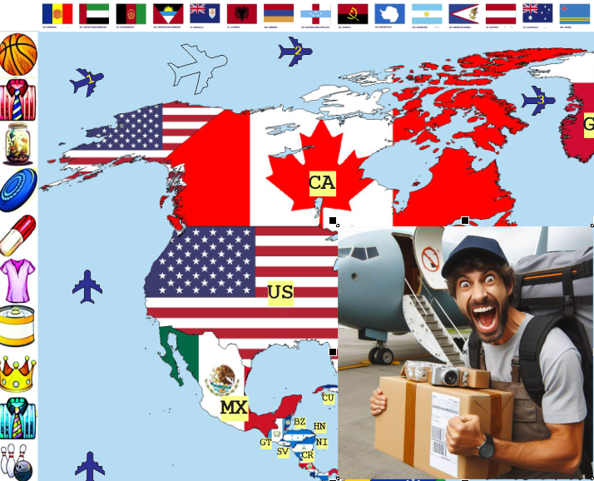

Initial Setup:
- Assemble the game board.
- Give each player a secrets holder, decoder board and dry erase marker.
- Shuffle the three sets of cards and place face down in a draw pile.
- Roll the die.
- Place the airplane on the matching number at top of the map.
- Place the Airplane Movement Card on the board.

Secrets Preparation:
Each player performs the following:
- Secretly takes one of each card from their respective draw piles: flag, parcel, unlock code.
- Takes their secrets holder such that the insert side (eyeballs) is facing them.
- Carefully inserts their three cards into their holder.
- Flips the holder face down.
- Slides the holder to the person another person, usually the person opposite them.
Each player then takes their new secrets holder and carefully flips it over such that the cards are visible only to the other players.

Game Modes:
- Cooperative: ALL players must decode ALL of their own their secrets before the courier completes his worldly travel.
- Quick Cooperative: all players only need to determine each of their secret country flags.
- Competitive: players compete to be first to decode all of their OWN secrets.
- Discovery: players cooperate to find countries on the map.
- Geo Grid: players drop flags onto a grid of attributes.

Cooperative Game Play:
In this mode, you are all playing against the courier, attempting to prevent him from completing his journey.
Taking turns, a player performs the following:
- Rolls the die
- Moves the airplane one or two spaces, or not at all, based on the courier’s Airplane Movement Card.
- Asks a question from their decoder form.
All players then view other player’s secrets and inform each player as to whether one of their secrets has matched the question. ALL Players either circle the answer to the secret or mark an “X” to eliminate the answer on their decoder form.
Usually the question is for all players to answer.

Asking a Common Question:
Using any of the questions on their decoder form, a player asks a question for all players to answer. For example, if the player asks “Is any country an island?”, all players call out whose country is an island and those matching players mark their answer on their decoder form.

Recording Your Answer:
Players either circle the answer to the secret or mark an “X” to eliminate the answer on their decoder form.

Attempting a Guess:
A player may attempt to guess one of their secrets only on their turn. The guess is made after the plane movement and after the question has been asked. Another player will respond with a “yes” or “no”.
If the guess is incorrect, advance the plane one space. If correct, the corresponding secret is removed from the secrets holder by another player and placed near the player.

Narrowing Down Secrets:
Examine your answers before attempting a guess. For example, if you think the country is Canada, you may have circled North America, six letters in country name and symbol in flag, but crossed off answers like “island” and “Spanish”.

Ending the Game:
Once everyones’ secret tiles have been guessed, the game is over. However, if the courier’s plane reaches plane location #1, the game is over, the courier wins and all players “lose”.

Competitive Game Play:
This mode is similar to cooperative play except the airplane is not used and you may ask “Advanced Questions” from the decoder form. Players simply compete to get first, second and third place wins. However, you are limited to six attempts as recorded at the bottom of your decoder. Maintain your score at the bottom as well.

Discovery Mode:
In discovery mode, players take turns flipping over flags and finding the country on the map. Use the country facts sheet to cooperatively find and share information. No scoring, just a fun way of learning about the location of countries.

Geo Grid Mode:
Give each player 10 random flags. Using the 6x6 Geo Grid, players take turns to dispose of their flags by matching a flag to an attribute. The person with the fewest flags remaining is the winner, once no more flags can be placed.

Strategies:
- Examine the ISO codes on the map.
- Mark clues on your decoder effectively.
- Avoid asking questions to help an opponent in competitive mode.
- Be sure when attempting a guess, as a wrong answer will advance the courier’s airplane.

FAQ:
?

Using the Country Facts Sheet:
The country facts sheet is indexed by two-letter ISO country codes. This is a standard international designation available in all languages.
For example, CA is the ISO code Canada and IE is Ireland. The fact sheet gives players the necessary information to answer questions.

Online Country Information:
Answers to questions such as the following
- Which countries are islands?
- Which country is in the Mediterranean area
- Which parcel is over?
- Which parcel is wooden?
are found online at www.brainy.games/parcel-panic

Solo Mode:
Use our web app to play a solitaire game. The web app will secretly select an item, airport and unlock code. You select the available questions to get answers. Surmise the item, airport and unlock code to win.
www.brainy.games/parcel-panic

SEND US A PHOTO OR VIDEO
Please post a photo or video of your family playing the game. Tag your image with @brainy.games and #parcelpanic on Instagram. We’ll mail you a free memory game as a thank you gift.

Copyright © 2024 Knowledge Probe Inc.
www.Brainy.games

